+–––

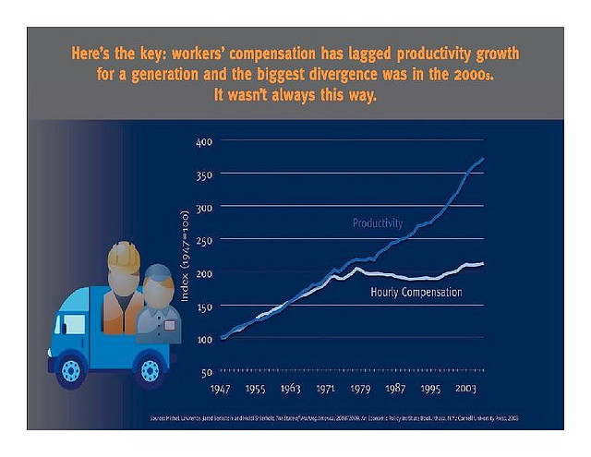

Productivity Wages

Note that blue graph above uses manufacturing productivity only, not overall productivity.

Therefore see: https://fred.stlouisfed.org/series/LABSHPUSA156NRUG

